

**MATHEMATICS  
METHODS**

**Test 2 – Equations, Polynomials, Functions and Graphs**

**Chapters 1 and 4**

**Semester 1 2016**

# 

**Section One - Calculator Free**

Time allowed for this section

Working time for this section: 20 minutes

Marks available: 20 marks

## Material required/recommended for this section

##### To be provided by the supervisor

This Question/Answer booklet

Formula sheet

##### To be provided by the candidate

Standard items: pens, pencils, pencil sharpener, eraser, correction fluid, ruler, highlighters

Special items: drawing instruments, templates, notes and up to three calculators satisfying the conditions set by the Curriculum Council for this course.

## Important note to candidates

No other items may be used in this section of the examination. It is **your** responsibility to ensure that you do not have any unauthorised notes or other items of a non-personal nature in the examination room. If you have any unauthorised material with you, hand it to the supervisor **before** reading any further.

1. (1 mark)  
   One or more errors have been made in the solution to this linear equation. State where the error(s) occurred.



A   Line 1 only B  Line 2 only

C Line 3 only D Line 1 and Line 2

E   Line 1, Line 2 and Line 3

1. (1 marks)  
   Which graph is not a function? Indicate on your choice your reason.

A 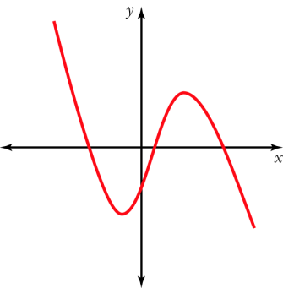 B 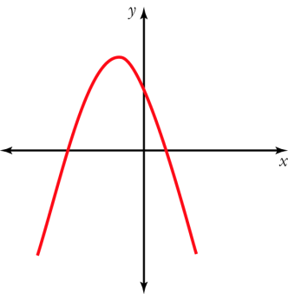 C 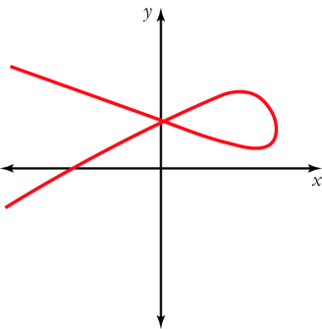

D 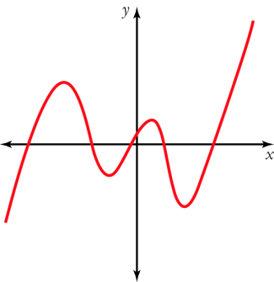 E 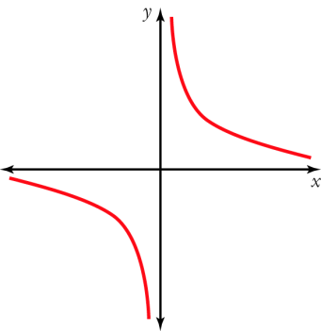

**Short Answer Questions**

1. (2 marks)   
   Solve 3 + 2(m – 4) = 4m – (3m – 2)
2. (4 marks)  
   Solve the following equations:
3. (3x – 2)(x + 9) = 0
4. x2 – 7x + 4 = 0 (using the quadratic formula)
5. (4 marks)  
   Mike had a pen with chickens and rabbits in it. Between them, the animals had 42 heads and 142 feet. Write equations and solve them to find out how many chickens and how many rabbits there were in the pen.
6. (8 marks)  
   Sketch the following functions:

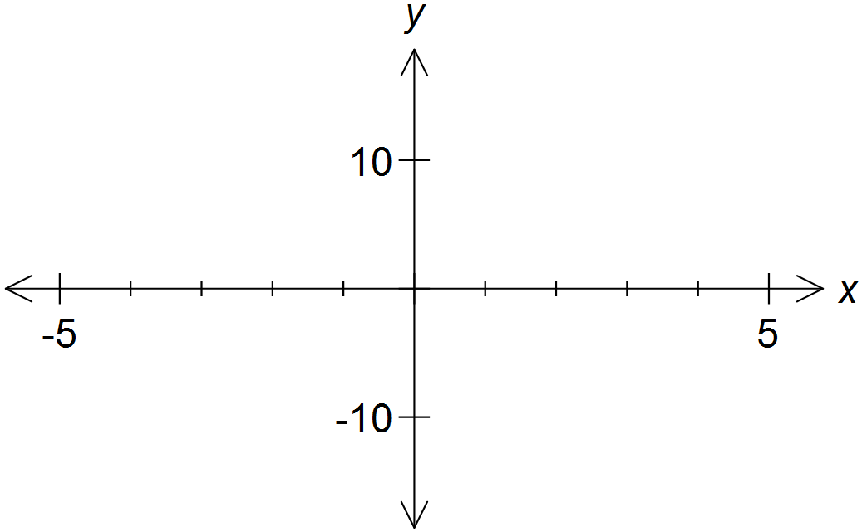

* 1. 

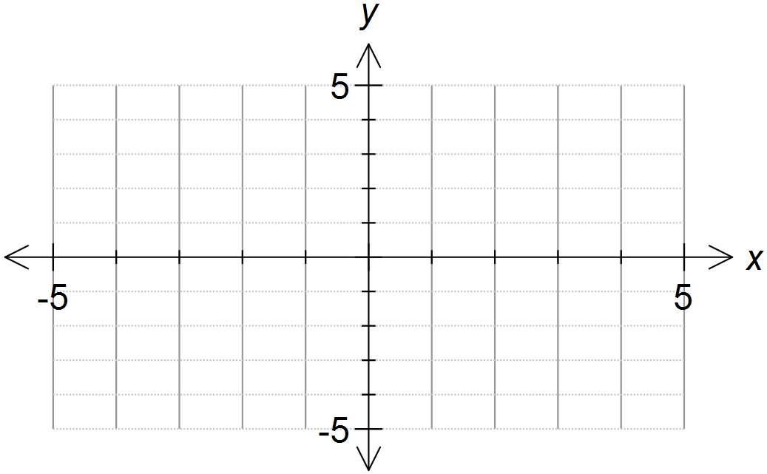

* 1. 

**End of Section One**